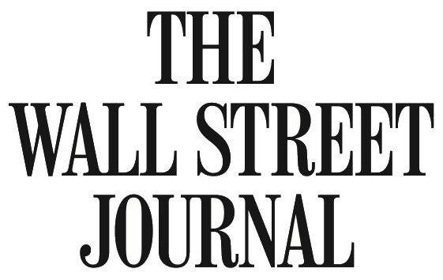
http://www.wsj.com/articles/congress-passes-gmo-labeling-rules-that-supercede-tough-state-measures-1468516761

BUSINESS

Congress Passes GMO Labeling Rules That Supersede Tough State Measures

In a victory for food companies, lawmakers override tough measures in Vermont and those considered elsewhere
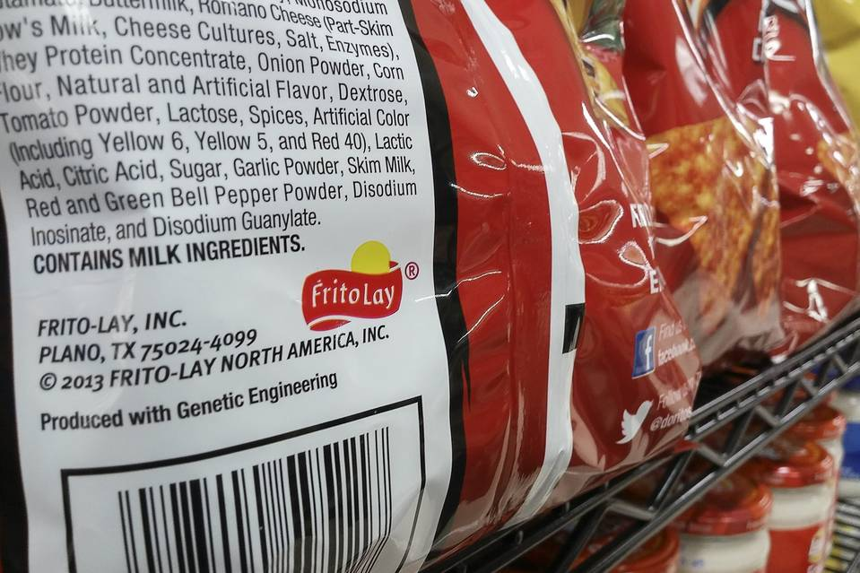
A law that took effect in Vermont required new labels sooner. PHOTO: RICHARD B. LEVINE/ZUMA PRESS
By
HEATHER HADDON
Updated July 14, 2016 1:54 p.m. ET
12 COMMENTS
In a victory for food companies, Congress has passed a federal requirement for labeling products made with genetically modified organisms that will supersede tougher measures passed by one U.S. state and considered in others.
The bill will require labels to be reworked or updated to show whether any of the ingredients had their natural DNA altered, but will take years to phase in and will give companies the option of using straightforward language, digital codes or a symbol to be designed later.
The terms are in contrast to a law that went into effect this month in Vermont. That law required food manufacturers and grocers selling prepared foods explicitly to label items that contained GMO ingredients by January. Companies that violate the law face fines of as much as $1,000 a day.
The compromise federal bill, which passed in the Senate last week and passed 306-117 in the House of Representatives on Thursday, is a likely relief for manufacturers, farm groups and biotechnology companies.
A White House spokeswoman said the administration anticipated signing the bill in its current form.
Andrew Kimbrell, executive director of the Center for Food Safety advocacy organization, said the environmental group is considering suing over whether the bill is discriminatory against certain groups if it becomes law.
GMOs, used in the U.S. for about two decades with federal approval, are crops whose genes have been engineered to make them resistant to pests, better able to withstand drought and otherwise hardier. Federal regulators have approved the GMO seeds on the market, but environmentalists and natural food supporters say they can hurt the environment and rely on herbicides that could harm consumers.
The vast majority of corn and soybeans grown in the U.S. is genetically engineered, and the Grocery Manufacturers Association trade group estimates that 70% to 80% of foods eaten in the U.S. contain ingredients that have been genetically modified.
The White House has stoked debate in mandating more disclosure of added sugar and highlighting calorie counts on food labels, but the push for labeling of GMO ingredients was fueled by a consumer backlash over their widespread use.
Critics of the new federal bill passed on Thursday say few customers will click on the digital QR codes displayed on labels by manufacturers that choose to use that method.
A study this year by the Food Marketing Institute, an industry group, found that only 20% of shoppers scan a digital code on grocery items to learn more about their nutritional content.
Some manufacturers already use digital codes on their labels, and the bill allows them to update the information they include without having to reprint their labels.
But Stonyfield Farm, a yogurt company that lobbied against the compromise bill, studied the use of QR codes for its products but found they were too cumbersome, said Britt Lundgren, a director at the New Hampshire company. “They are grossly inadequate,” she said. Stonyfield doesn’t use GMO ingredients and has lobbied for tougher rules.
The new federal legislation gives regulators as many as two years to write rules for the industry to follow nationwide in terms of labeling engineered ingredients, and small-food manufacturers would have three years to comply.
It also requires the U.S. Department of Agriculture to evaluate the effectiveness of digital symbols a year after the law is implemented.
The food industry has been in regulatory fights over GMO disclosure on labels for years. The earlier win for the pro-labeling movement in Vermont had sent food manufacturers and grocers scrambling.
Northeastern grocery chain Price Chopper, owned by New York-based Golub Corp., redesigned and labeled 7,000 store brands carried in its 135 stores across six states to comply with Vermont’s law, an undertaking that cost hundreds of thousands of dollars, a spokeswoman said.
The law has proven particularly confusing for grocers that must check multiple ingredients for GMOs in prepared foods and figure out the best way to display the information, said Jim Harrison,president of the Vermont Retail & Grocers Association. “There’s a lot of questions about how this all works,” he said.
Some big companies including Campbell Soup Co., General MillsInc., Kellogg Co. and Mars Inc. went ahead and began placing GMO-labeled items on store shelves several months ago nationwide either in response to consumer demand or Vermont’s law.
Danone SA said on Thursday that it would also begin to label GMO ingredients in yogurts made for the U.S. market. A Campbell spokeswoman said the U.S.’s largest soup manufacturer will continue to print labels with words related to GMO ingredients, and the company is in discussions with federal regulators about the language.
A Mars Inc. spokesman said the company is sticking with the text it has applied to products containing engineered ingredients for now. General Mills will review the regulations and assess consumer preference before developing its long-term plan on labeling, a spokesman said.
—Byron Tau contributed to this article.
Write to Heather Haddon at heather.haddon@wsj.com

